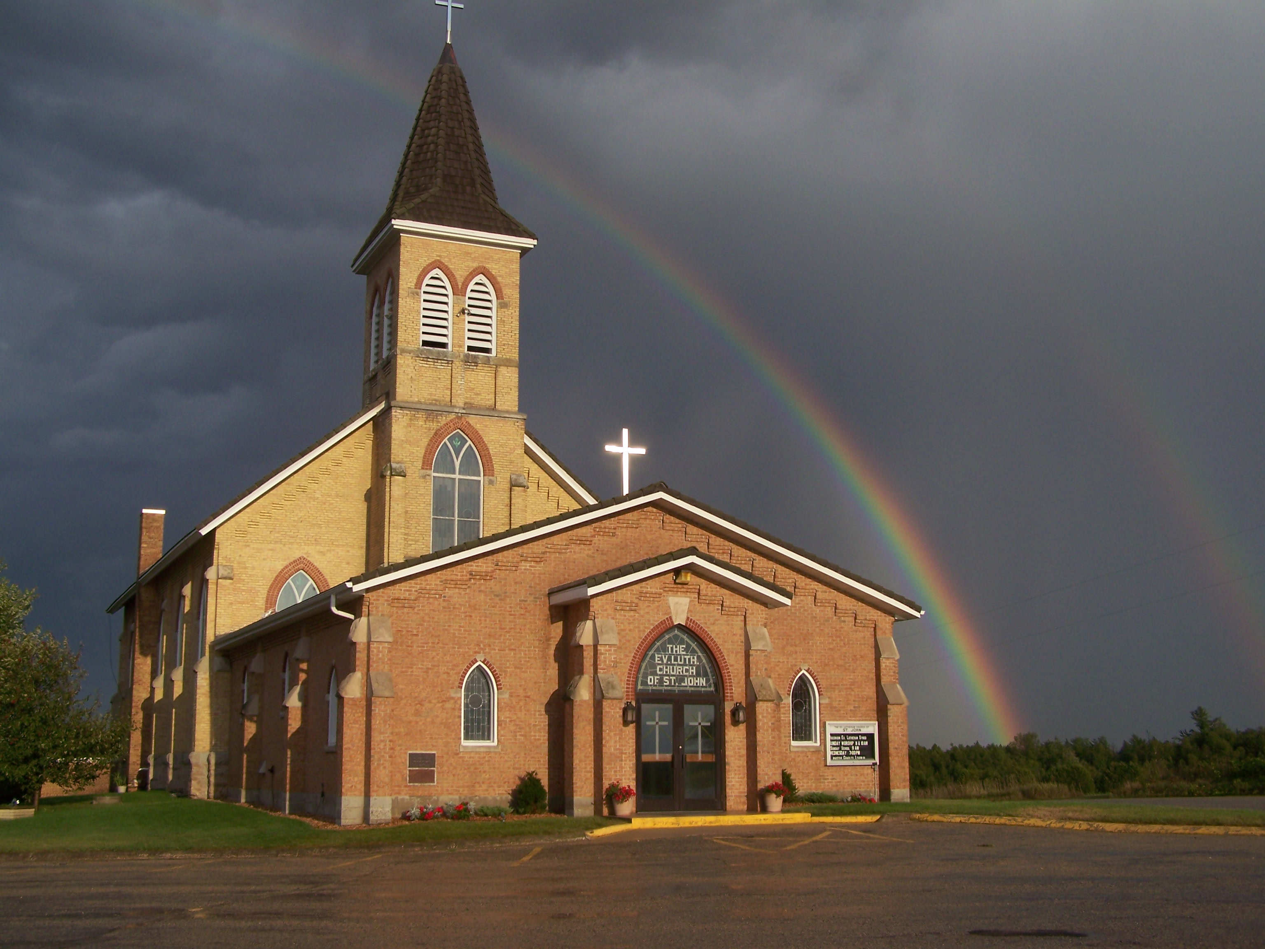
The Evangelical Lutheran Church of St. John
N1916 Church Road
Peshtigo, Wisconsin 54157-9673
Pastor Sargent 920-228-1061

07/09/20
Dear members of St. John,
Our theme for this Sunday is—Be alive in Christ! We will be looking at Romans 6:1-11. The emphasis is how we respond to the gift of Salvation God freely gives us.
“In the same way, count yourselves dead to sin but alive to God in Christ Jesus” (Romans 6:11)

Sunday the 12th of July will be the 6th Sunday after Pentecost.
Wesley Aguliar, our 6th through 8th Grade Teacher will be installed on Sunday the 12th of July at the 10:00 am service. A small reception to welcome him will be held after the service outside, weather permitting, with coffee and donuts.

Worship
We will worship with no more than 100 people in attendance for each service. At this time, we will not need to sign up before services because we have not gone beyond the occupancy limit.
If that happens, we will go to the sign up again.
- There will be two services on Sunday at 8:30 and 10:00.
- We will worship with no more than 100 people in attendance for each service.
- We will have portions of the church pews partitioned off to accommodate social distancing. Please be sure to sit only in the apportioned sections. Ushers will guide you to your seat of choice.
- No hymnals will be used. All service materials will be printed in the church bulletin, handed out to each member by an usher wearing a mask and gloves.
- We will not be passing offering plates in the worship service but will have them at the doors of the sanctuary where you may drop your offering.
- When church is over you will be ushered out. Please don’t get up and leave on your own. That will make it difficult to keep proper social distancing.
- We are not requiring that everyone wear a facemask, but please remember social distancing. If you feel comfortable wearing one, we encourage you to do so. Ushers will be wearing them.
Social Interaction

In order to maintain responsible social distancing, we are strongly encouraging the following:
- No physical contact: handshakes, hugs, fist bumps, etc.
- No gathering within church for socializing either before or after services.
- At this time all other church events, Bible Study, Sunday School, Ladies Aid and Quilting (etc.) will be on hold.

- If you are not feeling well or have concerns about your own health, you do not need to attend. We will continue with the Livestreaming service at 8:30. If you would like to receive private communion at home please contact Pastor Sargent.
These guidelines help us to be able to gather together at this time. If we all are willing to sacrifice for the good of those around us, we can make this work. Please, in all this, show patience and kindness to your brothers and sisters.


Reminder of Important Information:

Virtual VBS 2020


It is not to late to sign up your children for Virtual VBS

Here is the link. https://vbsmate.com/zionpeshtigo



Secretary Position Available (part time)
St. John Lutheran School
- St. John Lutheran School, N1924 Church Lane, Peshtigo WI, is looking to fill a new school secretary position.
- This position would consist of working 10-15 hours per week.
- The hours would be on- site from 8:00am-11:00am. However, setting the days and hours would be mutually agreed upon with the faculty and school board (for example, some hours could be done from home or done on certain days.)
- This person would be the friendly “voice of the school” to welcome visitors and potential school families.
- The secretary would need to be comfortable using the computer in order to email, publish a weekly newsletter, update the school website, go to and navigate various websites and keep accounting records for the school petty cash check book, etc.

If interested, please contact the Acting Principal Pastor Daniel Sargent for more information. The closing date for applications is Monday the 20th of July, 2020.
Email. pastorsargent@stjohnpeshtigo.org
Phone: 920-228-1061

Pastor Daniel Sargent

